1. Check for null values

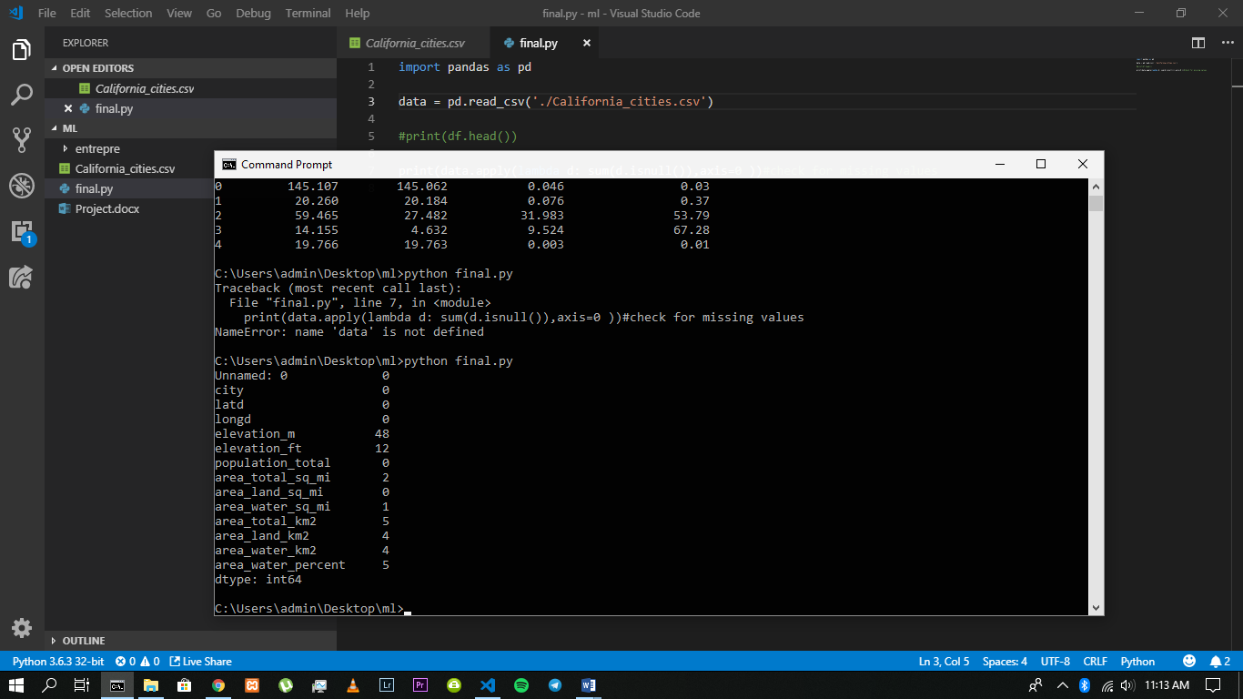

2. If there are null values replace them with either the (mean, medium, mode) of each column or drop all the rows altogether (i dropped the rows)

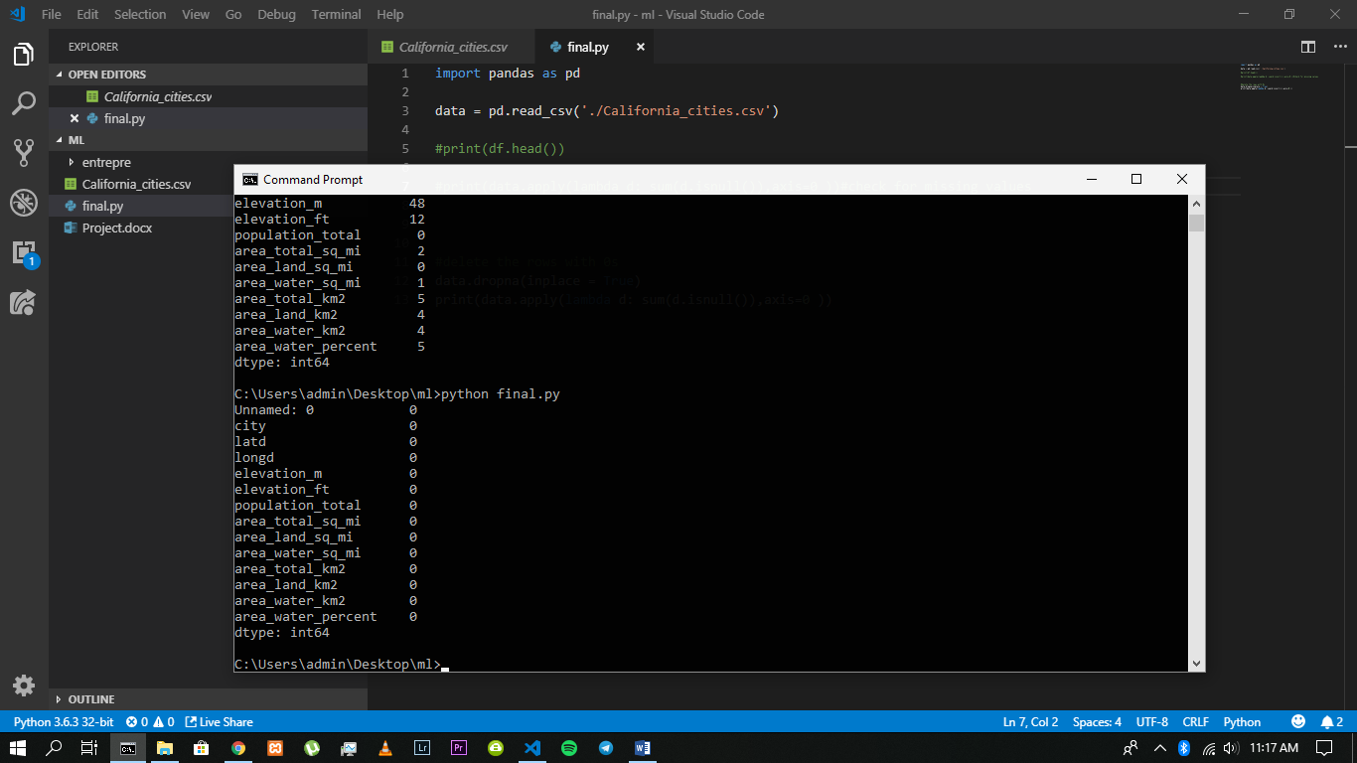

3. What is the mean, max, min, std, medium of the ten lowest values of

latitude values

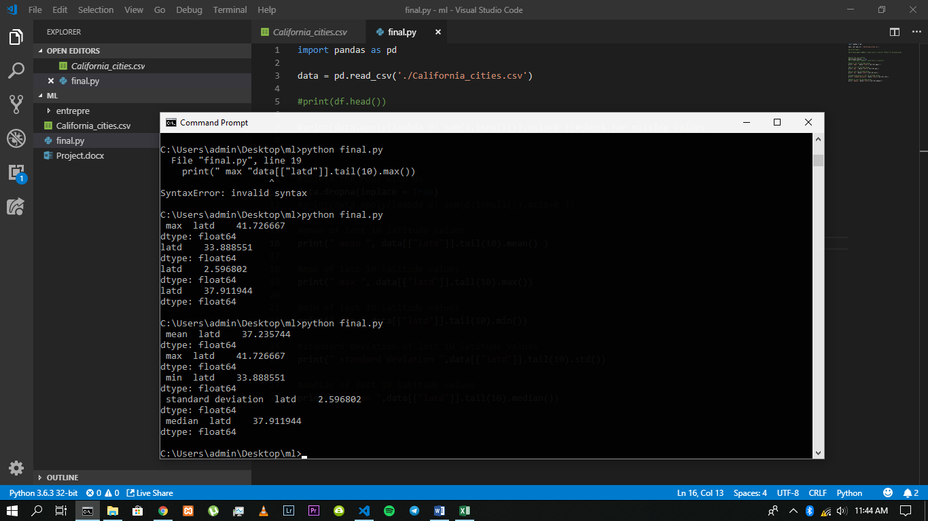

4. Display the ten cities with the least value of elevation in Meters

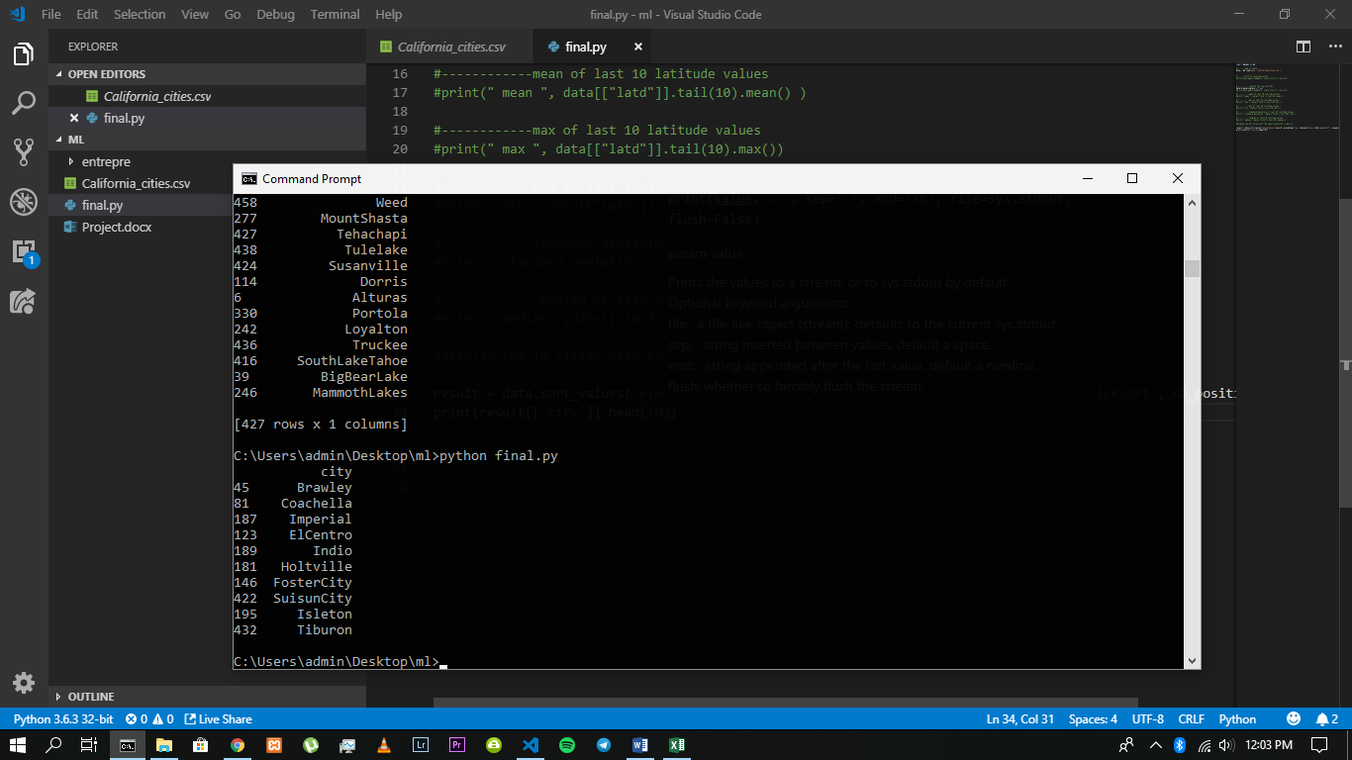

5. What are the top ten cities with the highest population totals

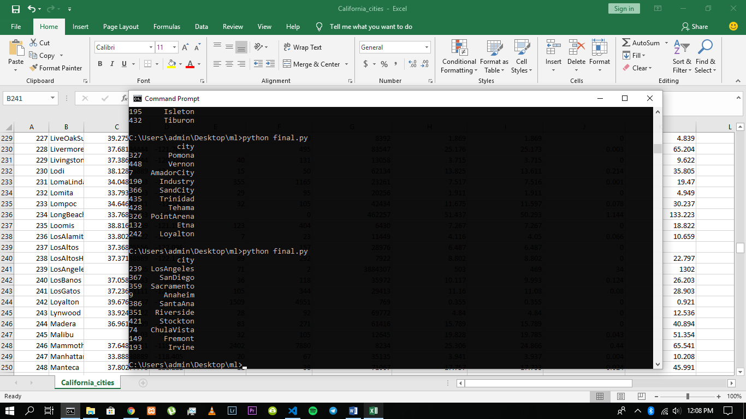

6. Plot the relationship of the top ten highest areas in feet with their respective population totals

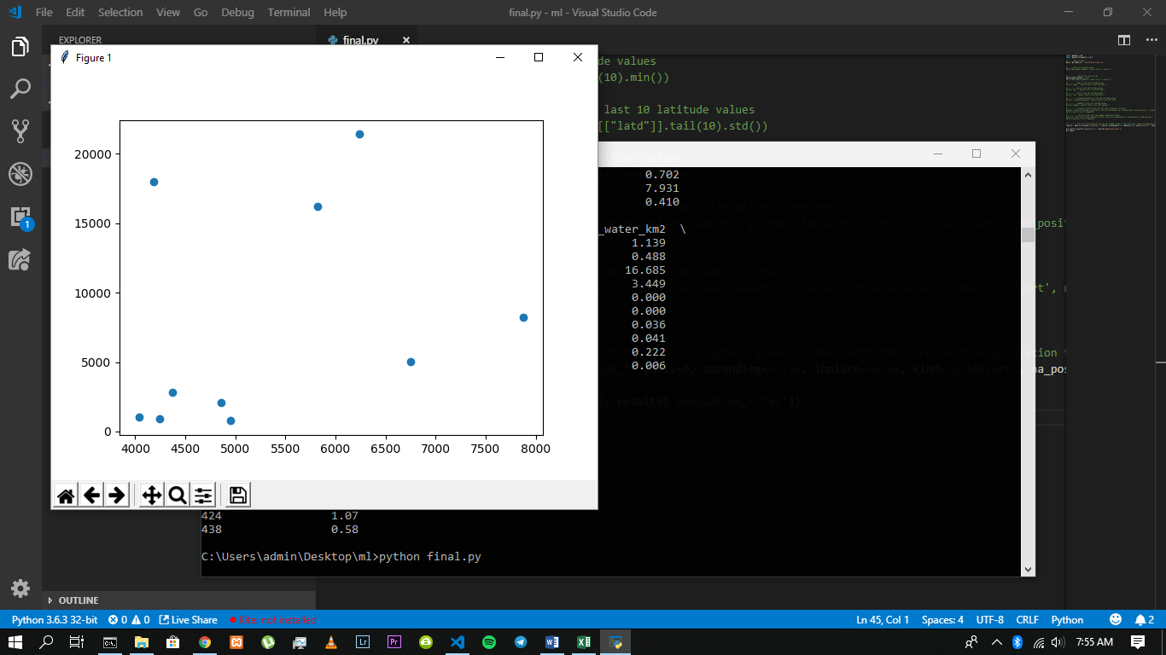

8. Plot a histogram of the area_total_sq_mi and describe the pattern of the data (you can use 20 bins for the histogram plot)

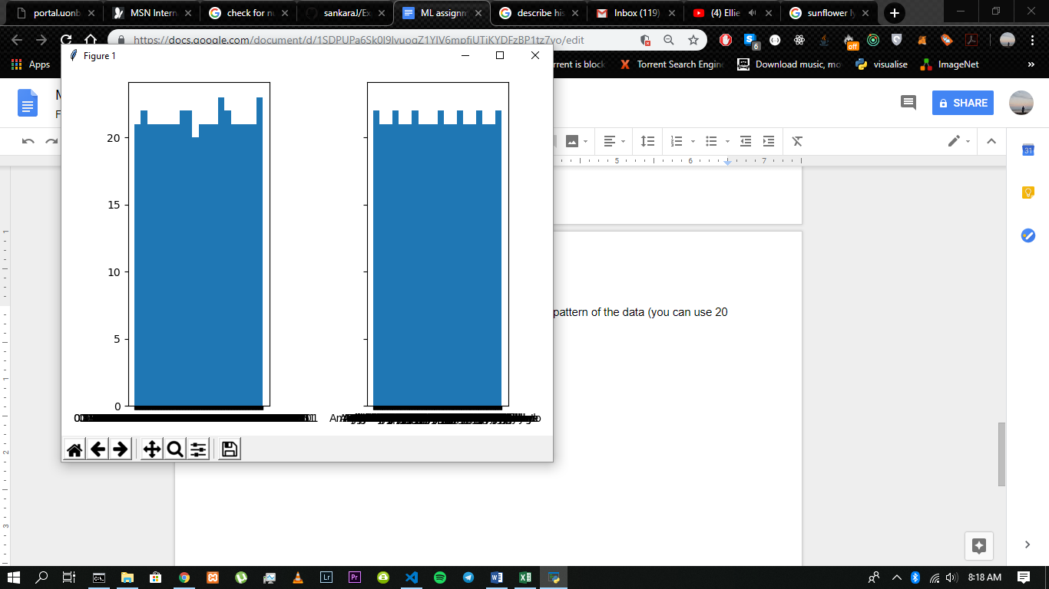

9. Normalize the values of the area_total_sq_mi, plot a histogram of the values and describe the pattern of the data after normalization.

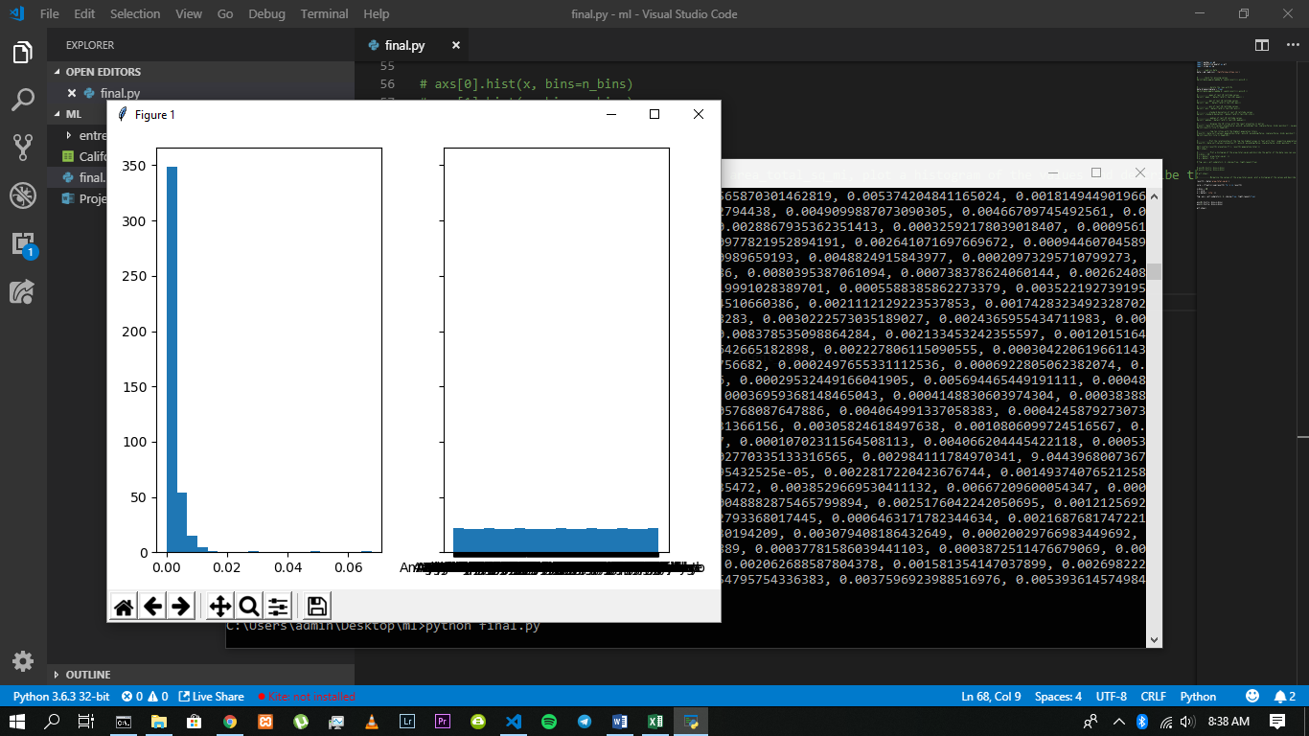

10.Using a plot analyze the relationship of the population total by the area

total in sq mi

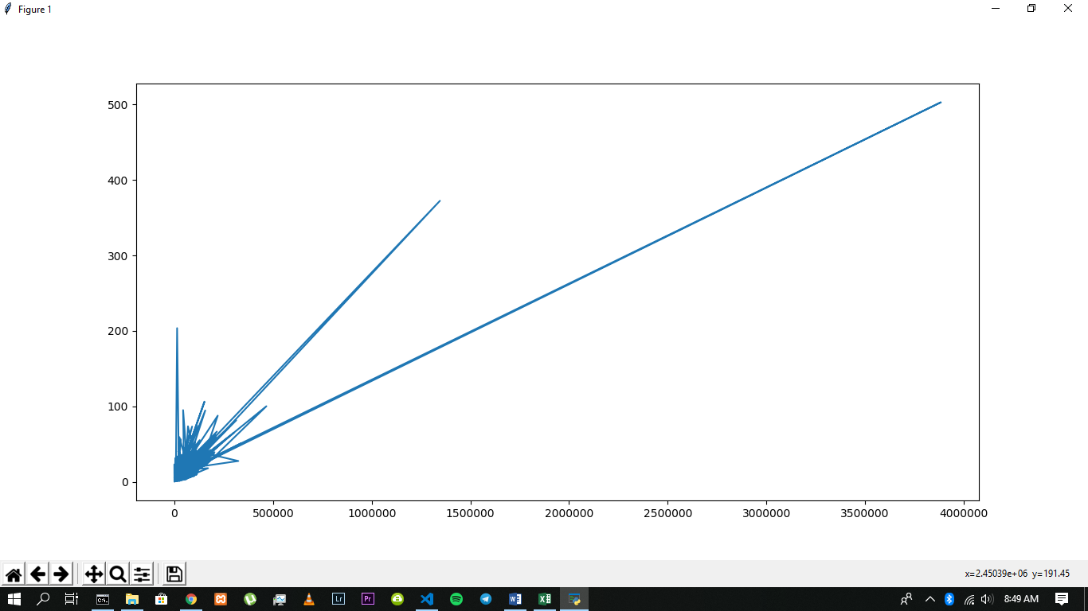

11. Assuming population_total to be our target value, fit the data onto a linear regression model and evaluate the performance of the model

